A Study of Orbital and Escape Velocity for Earth Satellites
Author: Prarthana Majhi
Affiliation: Undergraduate Student, Aerospace Engineering
Keywords: Orbital Velocity, Escape Velocity, Satellite Motion, Earth Orbit
Abstract
This paper presents a basic study of the orbital and escape velocity for satellites of the earths. The object is to understand how the gravity of the earth and the velocity of the satellite determines if the objects remains in the orbit or escapes the earths atmosphere. Equations and numerical values I have calculated by python. This is my first research paper I am trying to attempt.

Introduction
Artificial Satellite is a crucial element in our scientific research, communication, navigation and more. For the satellite to stay in the orbit it need to attain a specific orbit velocity or it can fall back due to the gravitational pull.

Things this paper is going to focus on:
- Orbital velocity
- Escape velocity
- Comparison of orbital and escape velocity

- Orbital velocity
Definition:
The velocity need at which the body circles around another body. The greater the mass of the body, the higher the orbital velocity for a given height or distance.
Space organisations heavy depend on this to launch their satellites into the space
It determines the speed at which the satellite should be launched and keep rotating around a celestial body while
Formula:
Vo= (M*G/R)^1/2

M= Mass of Earth
G= gravitational constant
R= Radius of Earth
1.2 Escape velocity
Definition:
It is the minimum speed need to break free the gravitational pull of the celestial body without any further population.
This is a scaler quantity that’s why it is refered to as the minimum speed to break free the gravitational pull. Meaning only the magnitude is matters not the direction, because what matters is overcoming the gravitational pull from the body and not the direction of the moment.
The formula for escape velocity derives from the law of conservation energy:
v_{e​} = (2GM/r​​)^{1/2}
Where:
- v_{e}​ is the escape velocity.
- G is the gravitational constant (6.674×10−11 Nm²/kg²).
- M is the mass of the celestial body.
- r is the radius of the celestial body from its center to the point of escape
Escape Velocity Table for Celestial Bodies
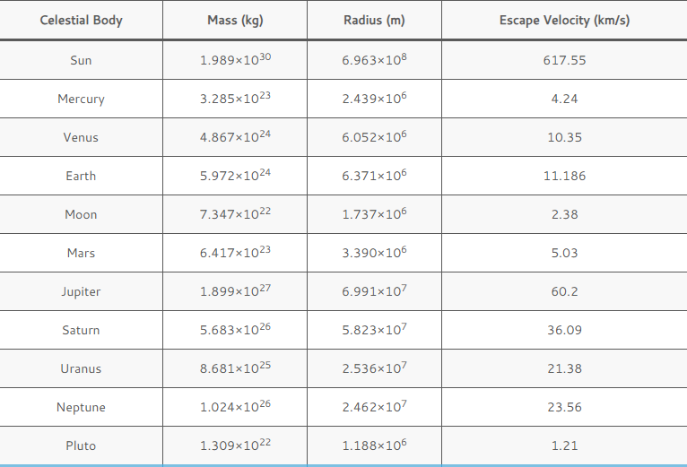

Methodology
The calculation was done using python programming language by taking the values of earth mass radius. Creating two separate function to calculate the orbit velocity and the escape velocity to ensure the code is reusable.
Discussion
The results show that orbital velocity is sufficient only to maintain circular motion around Earth, while escape velocity allows an object to break free from Earth’s gravitational influence entirely. This explains why rockets require much higher speeds than satellites intended for Low Earth Orbit.
Understanding these velocities is essential for:
- satellite mission planning
- launch vehicle design
- interplanetary missions
Conclusion
This study demonstrates the fundamental difference between orbital and escape velocity using analytical equations and numerical computation.
Future work may include:
- elliptical orbits
- velocity variation with altitude
- simulations using numerical method
Bibliography
- gigsforgreeks.org
- sciencenotes.org
- spaceplace.nasa.gov

